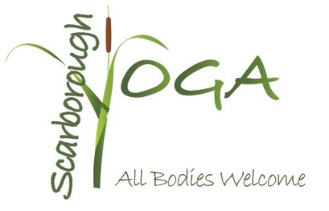
PARTICIPANT INTAKE FORM and WAIVER

Name | Date

Address
Home# | Cell#
Work# | Email
Emergency Contact | Emergency Contact #
Birthday | Male / Female

AGREEMENT OF RELEASE AND WAIVER OF LIABILITY

I ________________________________________________ hereby agree to the following:

- That I am participating in Yoga Classes workshops, or programs (collectively “the Program”) offered by Scarborough Yoga, LLC during which I receive information and instruction about yoga and health. I recognize that yoga requires physical exertion, which may be strenuous and may cause physical injury or death and I am fully aware of the risks and hazards involved. The risks include, but are not limited to, falls which can result in serious injury or death; injury or death due to negligence on the part of myself, or other people around me; injury or death due to improper use or failure of equipment; strains and sprains; those risks caused by facilities, temperature, weather, condition of athletes, equipment, actions of other people including, but not limited to, participants, spectators, trainers, and lack of hydration. I am aware that any of these above mentioned risks may result in serious injury or death to myself. I willingly assume full responsibility for the risks that I am exposing myself to and accept full responsibility for any injury or death that may result from participating, volunteering or watching the Program.

2. I understand that it is my responsibility to consult with a physician prior to and regarding my participation in the Program. I represent and warrant that I am physically fit and I have no medical condition which would prevent my full participation in the program. I acknowledge that I have no physical impairments, injuries, or illnesses that will endanger me or others.

3. In consideration of being permitted to participate in the Program, I agree to assume full responsibility for any risks, injuries, or damages known or unknown, which I might incur as a result of participating in the Program.

4. In further consideration of being permitted to participate in the Program, I knowingly, voluntarily, and expressly waive any claim I may have against Scarborough Yoga and/or my yoga instructor or that I may sustain as a result of participating in the Program. I realize that liability may arise from negligence or carelessness by the persons or entities being released, from dangerous or defective equipment or property owned, maintained or controlled by them or because of their possible liability without fault.

5. In consideration for my being allowed to participate in the Program, I hereby release Scarborough Yoga, LLC and its principals, agents, employees, and volunteers from any and all liability, claims, demands, actions or rights of action, which are related to, arise out of, or are in any way connected with my participation in the Program, including those allegedly attributed to the negligent acts or omissions of the above mentioned parties. This agreement shall be binding upon me, my successors, representatives, heirs, executors, assigns, or transferees. If any portion of this agreement is held invalid, I agree that the remainder of the agreement shall remain in full legal force and effect.

I have read the above release and waiver of liability and fully understand its contents. I voluntarily agree to the terms and conditions stated above. I understand that by signing this agreement I am waiving valuable legal rights.

This Agreement is valid unless and until revoked by Participant in writing.

Date __________________

________________________________________
Signature of Participant, or signature of
Parent/Guardian if under 18

